


The 4-H Newsletter






Calendar of Events
FEBRUARY
6: Valentine Cards Due
6: Food Challenge Reg. Deadline
6: Sea Perch Reg, Deadline
12: Jr. Leader Meeting
13: Mardi Gras Float Judging
13: Honor Cord Apps. Due
14-21: State Livestock Show
26: Sewing Club
18: Senior Scholarship Apps. Due
25: Livestock Banquet
27: Person of Char. Essays Due

MARCH
4: 4-H U Info Meeting
6-8: JLC
10: Food Challenge
12: Jr. Leader Meeting
20: Safety Poster & Slogans Due
22-Apr 4: Southern Regional Shooting Sports Matches
23: Spring Cookery Drop-off
26: Sewing Club
27: Records and Portfolios Due

APRIL
8: Lego STEM Camp
10-18: State Shooting Sports Competition
14: Jr. Leader Mtg
23: Sewing Club
St. James Parish February 2026



Beef, Seafood & Egg Spring Cookery
EGG: The prepared dish must utilize a minimum of 4 eggs, this can be 4 whites, 4 yolks, or 4 whole eggs. The divisions are:
1. Appetizer/Side Dish 2. Main Dish/Salads 3. Dessert
BEEF: 4-H’ers must prepare a dish which contains a minimum of one pound of beef.
The divisions are:
- Ground Beef 2. Other Beef Cuts
SEAFOOD: 4-H’ers must prepare a dish that contains a minimum 1 cup of seafood. The Seafood must be fresh, frozen, pasteurized, or dried. The divisions are:
- Crab 2. Crawfish 3. Shrimp 4. Other Louisiana Seafood (Must be listed on the Louisiana Seafood List – found in separate packet)

Monday, March 23rd, 2026
Dish Drop-off: 7:30am-6:00pm
All dishes will be judged on Tuesday, March 24th and winners will
be announced on our Facebook page.

Contest Rules
All rules will be strictly enforced. If you have a question, call the 4-H Office before preparing a dish.
- The contestant must be a 4-H member, all division are open to any age.
- All dishes must be prepared following all food safety guidelines from the USDA and can be found at www.FoodSafety.com.
- A contestant may enter as many dishes as they wish but can only enter one dish per division.
- Winning recipes may not be repeated in subsequent years by the same contestant.
- Contestants may only use one recipe/category.
  - Example: A contestant may not enter a jambalaya recipe in poultry and again in rice.
- The dish needs to be in a disposable plastic container, with a hard lid, with only 1 to 2 servings inside. (Dish Presentation is not a concern for the parish contest)
- There are to be NO raw eggs in the final product.
- Entries must meet all division requirements.
- One TYPED recipe must accompany the dishes.
  - Recipes will be scored according to the Recipe Evaluation below.
- All dishes must be brought to the contest completely chilled in an ice chest on ice. Judges will heat up dishes if needed.



Valentine Card Contest
This is a service project to honor senior citizens. After the contest, all cards will be given to senior residents of St. James Parish at Chateau St. James and Beacon Behavioral Hospital residents.
Instructions:
- Create a sturdy Valentine card appropriate for a senior citizen. Your card will be judged on the FRONT design only. Be creative and colorful. You may glue or attach small decorations to the card, but no wire or glitter is allowed. 3-D designs are allowed.
- Neatly write one of the verses below in the inside of your card, using your school 4-H Club.
- Cut out and complete the ENTRY FORM below. Paper clip/Tape it to the BACK of your Valentine card.
- Bring your Valentine card to school by Friday, February 6th.
Roses are Red,
Violets are Blue,
It’s Valentine’s Day,
And we care about you!
Happy Valentine’s Day
_______ 4-H Club
Sending you loving thoughts and good wishes to make your day happy!
Happy Valentine’s Day! ________ 4-H Club
Flowers and hearts are the decoration for this kind of celebration!
Happy Valentine’s Day _________4-H Club

Valentine Card Contest Registration Form

Name: _________________________________________

School: _________________________________________

Age: ________________ Grade: ____________________

Person of Character Essay
Martin Luther King, Jr. was an important American who exemplified great character. DO YOU KNOW SOMEONE WHO HAS GREAT CHARACTER? Maybe a relative, friend, teacher, pastor/priest, coach, elected official, or business owner?
Tell us about who you would choose as a PERSON OF CHARACTER! Write a SHORT ESSAY describing this person. Your essay should have between 200 and 500 words.
ALL ENTRIES MUST BE TURNED INTO THE 4-H OFFICE BY FRIDAY, FEBRUARY 27th.


Follow these guidelines when entering the Essay Contest:
1. You must personally know the person you are writing about. In the essay, briefly tell how you know the person.
2. The essay should have a title and describe the character of the person selected, using at least one of the Pillars of Character.
3. This is a short essay contest. Use between 200 and 500 words.
4. You may neatly hand-write or type your entry.
5. Attach a page with YOUR NAME, SCHOOL & GRADE on your essay.

Senior Honor Cord Applications
In an effort to recognize graduating 4-H seniors, the Louisiana 4-H Foundation sponsors the 4-H Honor Cord Award. Please visit the following 4-H Honor Cord application link for award criteria and information.
For 4-H youth to receive the 4-H Honor Cord, they must meet the following requirements:
- Be a currently enrolled 4-H member and in good standing
- Must be a graduating senior.
- Must have been enrolled in 4-H for at least 3 years in high school.

- Must have participated in at least one state sponsored 4-H program in the past 3 years, or demonstrated exemplary parish-level program involvement.
- Must complete the application form by the deadline.
2023-24 4-H Honor Cord qualification information and application link:
https://www.lsuagcenter.com/topics/kids_teens/events/awards/recognition-and-opportunities/senior-honor-cords
Applications are due Friday, February 13th at 11:59pm!
Mardi Gras Float Contest
- Mardi Gras Floats can be made from cardboard boxes including show boxes, cereal boxes, mailing boxes, etc. but should NOT EXCEED 12 inches wide and 18 inches tall (should be able to fit on a table top and be easily carried/transported)
- Stickers, paper, pipe cleaners, paint, beads, and other festive decorations or craft supplies may be used.
- Wheels may be added to floats (optional) but floats should stay within size requirements.
- NO glitter!

- You may only enter ONE float in ONE of the categories for judging. You are only allowed one entry into the contest.
- Each entry will receive a Blue, Red, or White ribbon.
- 4-Hers will select one of the following categories to enter their float in:
  - Most Mardi Gras Spirit
  - Most Original
  - Most Creative
  - Most 4-H Spirit
- An overall winner for each category will be chosen for each age division.
  - Elementary (4th-6th); Junior (7th-8th), and Senior (9th-12th)
Floats will be judged on FRIDAY, FEBRUARY 13TH at each school.


Senior Scholarships:
4-H State Scholarships
- Applicable to any 4-H senior
- Applications due Wednesday, February 18th
4-H Golden Clover Award 4-H Emerald Achievement Award
-Students 14 and under -15 years of age (or older)
-Must have at least 2 years of 4-H club work. -Must have 3 years of 4-H club work.
*Contact 4-H office for Application* -Must have completed one year of active Junior Leadership work.
*Contact 4-H office for Application*

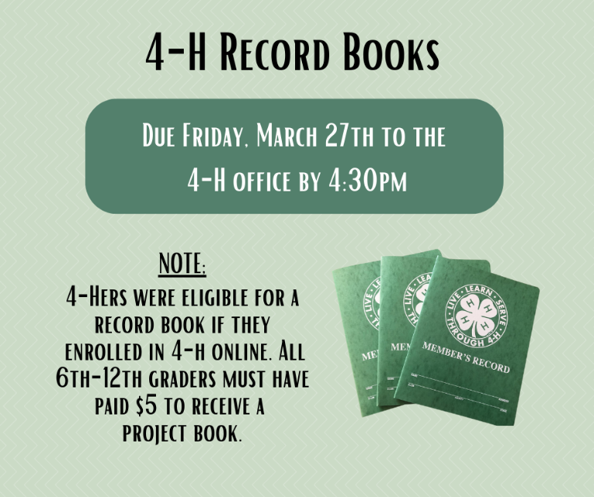

Welcome 4-Hers!
Carly B. Dufresne Laynie A. Smith
Associate Extension Agent Associate Extension Agent
cmboudreaux@agcenter.lsu.edu larceneaux@agcenter.lsu.edu

2204 S. Albert Street
Lutcher, LA 70071
(225) 562-2320

ADA: If you need a special accommodation for your participation in the event, please contact the office at 225-562-2320 at least two weeks prior to the event.
EEO: The LSU AgCenter is a statewide campus of the LSU System and provides equal opportunities in programs and employment.

